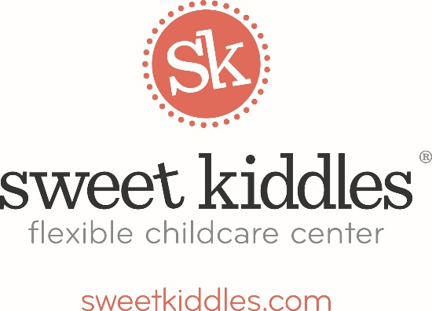

Sweet Kiddles Early Childhood Health Referral Process

Sweet Kiddles cannot stress enough the importance of comprehensive early childhood health screenings.

Comprehensive screenings include, but are not limited to, the following:

Vision Hearing Dental Height Weight

Blood Lead Levels Hemoglobin Levels

Since we require a valid medical statement from our children in attendance, most of you already have access to regular screenings.

HOWEVER, if your local pediatrician/doctor has not kept on top of these screenings OR your child does not get to a dentist 2x/year, please consider seeking additional services.

The Cuyahoga County Board of Health has a plethora of information on how to access comprehensive health screening services in Cuyahoga County.

Cuyahoga County Board of Health
550 Venture Drive
Parma, OH 44130
(216) 201-2000
http://www.ccbh.net/

