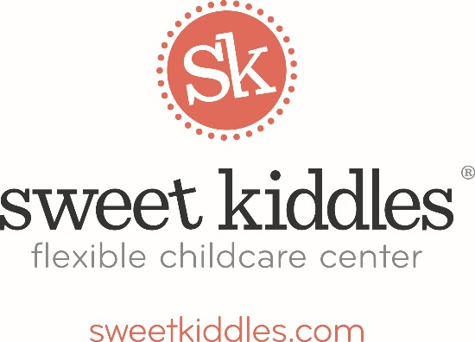

Sweet Kiddles Early Childhood Health Referral Process

Sweet Kiddles cannot stress enough the importance of comprehensive early childhood health screenings.

Comprehensive screenings include, but are not limited to, the following:

Vision Hearing Dental Height Weight

Blood Lead Levels Hemoglobin Levels

Since we require a valid medical statement from our children in attendance, most of you already have access to regular screenings.

HOWEVER, if your local pediatrician/doctor has not kept on top of these screenings OR your child does not get to a dentist 2x/year, please consider seeking additional services.

The Summit County Board of Public Health has a plethora of information on how to access comprehensive health screening services in Summit County.

Summit County Public Health
1867 W. Market Street
Akron, OH 44313
(330) 923-4891
http://www.scph.org

