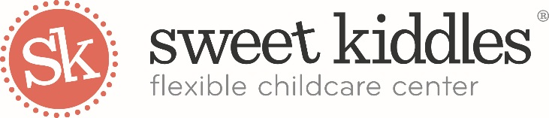

Sweet Kiddles’ Strongsville Community Resources Information
Revised September 2022

Cuyahoga County Public Library – Strongsville Branch
http://www.cuyahogalibrary.org/Branches/Strongsville.aspx
Southwest General Hospital
http://www.swgeneral.com/
18697 Bagley Rd
Middleburg Heights, OH 44130
(440) 816-8000

Southwest General is a non-profit hospital in Ohio serving southwestern Cuyahoga, northern Medina and eastern Lorain counties.
Cuyahoga County Board of Health
http://www.ccbh.net/
5550 Venture Drive
Parma, OH 44130
216-201-2000

The Cuyahoga County Health Department works to promote physical and mental health and well-being; prevent disease, injury and disability; promote a healthy environment; and prolong life.
Cuyahoga County Board of Developmental Disabilities
http://www.cuyahogabdd.org/
Although the community knows the Board of DD best for adult activities centers and group homes, we offer a full range of services, everything from in-home early intervention programs for very young children and their families to leisure programs for seniors and specialized therapies (speech-language, occupational and physical), psychological services, support administration, family resources and respite care, supported living, vocational training, community employment, rehabilitation engineering and crisis intervention.

United Way of Greater Cleveland
http://www.unitedwaycleveland.org
Here in Cleveland, as well as across the country, United Way is committed to advancing education, income and health to create better communities for all. Our aspirations are for every child to graduate from high school, for every family achieve and maintain financial stability and for all to enjoy good health. By mobilizing our community to give, advocate and volunteer, our intention is to make our aspirations reality, right here in Greater Cleveland.
Starting Point
Starting Point is Northeast Ohio’s child care, early education and out-of school time resource and referral agency. Serving families, youth, professionals and the community.
http://starting-point.org/
eParent
www.eparent.com
Information support and outreach for parents and families of children with disabilities
Family Education
http://www.familyeducation.com/
A well-organized parent advice, child development and family reference website.
Help Me Grow
Helpmegrow.org
Offers services and support to help Ohio’s children start school healthy and ready to learn.
Zero to Three
http://www.zerotothree.org/
ZERO TO THREE's mission is to promote the healthy development of our nation's infants and toddlers by supporting and strengthening families, communities, and those who work on their behalf.
Born Learning
Bornlearning.org
Born Learning helps parents, caregivers and communities in Summit County create quality early learning opportunities for young children.
Ohio Child Care Resource & Referral Association
http://www.occrra.org/
Ohio Child Care Resource & Referral Association promotes the positive development of all children, especially those in out-of-home learning environments.
Child Care Aware
http://www.childcareaware.org/
Child Care Aware is a non-profit initiative committed to helping parents find the best information on locating quality child care and child care resources in their community.
Ohio Department of Job and Family Services
http://jfs.ohio.gov/families/index.stm
Information on ODJFS programs including adoption/kinship/foster care, child care, child support, protective services, financial assistance, health care, food stamps, and links to other sites for information on food banks, clothing, shelter and transportation can be found from links off of this page.

SPROUT Therapy (Speech, Occupational and Behavioral Therapies)

https://www.sprouttherapyllc.com/about
​
We are a clinic in Northeast Ohio serving the pediatric and adult populations. We offer direct (individual and group) Speech and Occupational therapy as well as consultative services. Located in Strongsville, Ohio, we provide services in the convenience of your own home, community, and in daycare facilities throughout Northeast Ohio. We are also proud to partner with the Strongsville Recreation Department and Beyond Words to serve the community through Camps for all age groups to enhance speech and language skills throughout the year.

